NES Medical Directorate - The Scotland Deanery

Educational Governance of Postgraduate Medical Education and Training in Scotland

Overview

NHS Education Scotland (NES) is a special Health Board within NHS Scotland responsible for the development and delivery of education and training for all those who work in NHS Scotland, including doctors in training.

ERGC

NES Board

ERGC

SLMT

MDET

Figure 1: Medical Directorate Governance Structure

The NES Medical Directorate through the Scotland Deanery has primary responsibility for the education and training of doctors as well as significant responsibilities for the appraisal and revalidation of all doctors in Scotland. The Medical Directorate Executive Team (MDET), led by the NES Medical Director, reports to the NES Board via Senior Leadership and Management Team (SLMT) and the Education and Research Governance Committee (ERGC), both of which are full sub-committees of the Board.

The Scotland Deanery is tasked with ensuring that all aspects of education and training meet the standards set out by the General Medical Council, in its key policy document Promoting excellence: standards for medical education and training.

The NES Medical Director fulfils the statutory role of Responsible Officer for all doctors in training in Scotland, to ensure that all GMC standards are met or exceeded. The Medical Directorate together with its partners and important stakeholders including the GMC, British Medical Association (BMA), NHS Boards, Scotland’s Medical Schools and Medical Royal Colleges works to secure first class education and training that meets or exceeds all regulatory standards and acknowledged best practice in Postgraduate Medical Education and Training (PGMET).

The Scotland Deanery is supported by a matrix of four operational workstreams and four regions across Scotland:

Workstreams
Training Programme Management
Quality Management
Professional Development
Strategic Planning and Directorate Support

Regions
North Region
East Region
West Region
South-East Region

with regional offices in Aberdeen, Inverness, Dundee, Glasgow and Edinburgh.

This matrix structure approved by the NES Board in 2012, and subsequently implemented, provides the appropriate blend of operational capacity and regional focus for the Medical Directorate and the Scotland Deanery. The Postgraduate Deans, GP Directors and General Managers work across both axes to deliver unified approaches for Scotland, to achieve consistent delivery against regulatory standards whilst retaining the vital regional knowledge, expertise and responsiveness through working closely with Scotland’s five medical schools, fourteen territorial Health Boards and Local Education Providers (LEPs).

In fulfilling the role of Lead Dean/Director (LDD) for one or more of eight Specialty Groupings based on the Scotland Deanery’s eight Specialty Training Boards, Postgraduate Deans and General Practice Directors assume the role of delegated Responsible Officer for all trainee doctors in the grouping.

The LDD has unequivocal accountability for all “standard” aspects of training and education in their assigned Specialty Grouping(s), primarily including how programmes are organised and delivered and how the quality of that education and training is continually improved. Furthermore, LDDs have delegated Responsible Officer revalidation responsibility for their specialty grouping whilst “non-standard” aspects of training management remain the responsibility of the Regional Postgraduate Dean, where local context and linkages with Health Boards, LEPs and Universities may be important.

The NES Board is linked directly to individual trainees in their training programmes through a transparent and clear chain of assigned accountability, strengthened by links to relevant partners, at both national and local levels, that is securely underpinned by the infrastructure found within the Medical Directorate’s Workstreams and Regions.

How we govern training programmes in Scotland

The Training Management (TM) Workstream is responsible to the Medical Director via the Medical Directorate Executive Team (MDET) for the operational activity associated with programmes. The Workstream reviews all programmes annually to ensure best practice and to develop action plans to address any identified concerns. The TM Workstream ensures that Scotland Deanery-wide policies and procedures are in place for all aspects of programme management and oversees the Scottish contribution to UK recruitment for programmes. Its remit is to ensure that all policies and procedures accord with the GMC, and to the UK Reference Guide to Postgraduate Specialty Training in the UK or “Gold Guide, 7th edition January 2018”, and best practice employment standards.

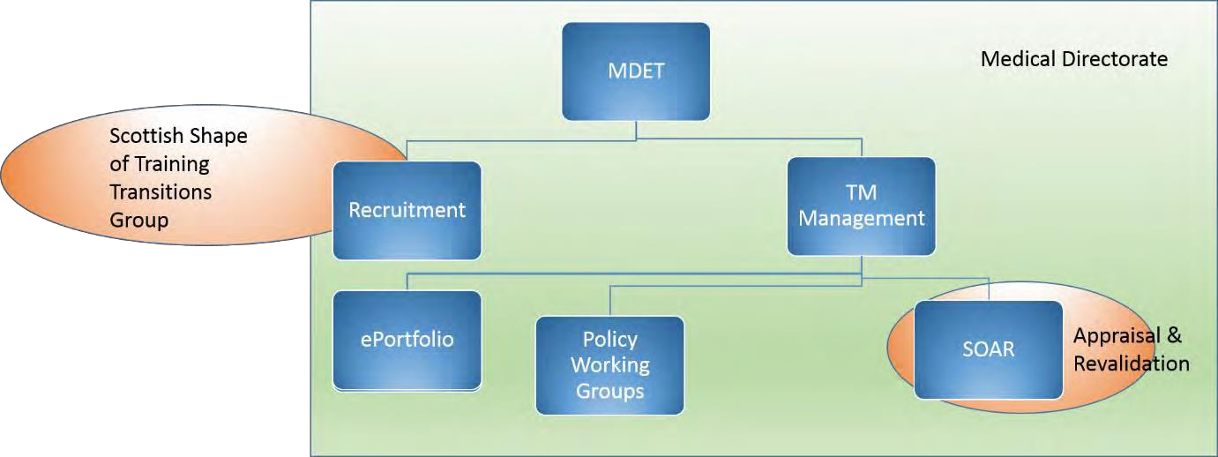

Figure 2. Governance structure of Training Management and wider reporting structures

MDET oversees all aspects of Medical Directorate activity, and all workstreams report to MDET. The TM Management Group consists of the three LDDs, the General Manager and the Senior Training Manager. Reporting into this are the TM Leads Group, including the regional Training Managers, the ePortfolio Group and the various policy working groups.

Policy and standards for postgraduate medical education are governed by the GMC standards ‘Promoting Excellence” and by the “Reference Guide to Postgraduate Specialty Training in the UK” or Gold Guide, 7th edition January 2018, developed under the umbrella of CoPMED and approved by the 4 UK Departments of Health.

Standards for recruitment are agreed at UK level through UK Medical and Dental Recruitment and Selection (MDRS) and are available in the relevant applicant’s guide. Standards for system development and information governance are set by NES internal policy.

Accountability for ‘standard’ programme activity lies with the LDDs for each of the eight specialty groupings (see below) which are aligned to one of the Scotland Deanery’s Specialty Training Boards (STBs), while accountability for ‘non-standard’ activity lies with the relevant regional Postgraduate Dean or GP Director.
- Foundation
- General Practice, Occupational Health, Public Health
- Medical Specialties
- Surgical Specialties
- Obstetrics and Gynaecology + Paediatrics
- Anaesthetics, Emergency Medicine and Intensive Care Medicine
- Mental Health Specialties
- Diagnostic Specialties

Associate Postgraduate Deans (APGDs) and Assistant GP Directors (APGDs) are professionally accountable to the LDD for the Specialty Training Board concerned in respect of standard programme management issues and accountable to the regional Postgraduate Dean (for hospital programmes) or GP Director (for GP programmes) for all non-standard issues, effecting, in practice, direct extension of the delegated Responsible Officer role.

Trainees in training programmes, whether for specialty, general practice or foundation training, are managed by a Training Programme Director (TPD) who is accountable to the relevant Associate Postgraduate Dean. Within each programme, each hospital or training location requires at least one Educational Supervisor for trainees. Trainees must have named educational and clinical supervisors who are recognised as such by the GMC. These educational governance arrangements are underpinned by financial Service Level Agreements between NES and its partner Health Boards, who are responsible for LEPs.

Some programmes are organised nationally (pan-Scotland) and some locally depending on the number of trainees in the programme and the training locations

Training Programme Directors, as Scotland Deanery representatives, retain a regional focus centred on delivery and adherence to UK national and Scotland Deanery policies and processes for all aspects of programme management, promoting equity and fairness as a result.

The Scotland Deanery’s Specialty Training Boards are chaired by an appointed STB Chair and act as important advisory bodies for all aspects of training management, providing expert Scotland-wide external perspective and advice to the LDD for each Specialty Grouping: strengthening accountability and overall governance via the LDD and onwards to MDET, the Medical Director, and the NES Board.

How we govern quality in Scotland

A core function of the Scotland Deanery is to effect the quality management (QM) of postgraduate medical education & training. This requirement is embedded in statute and the Deanery is a pivotal component of the GMC's Quality Assurance Framework – see figure 4 below.

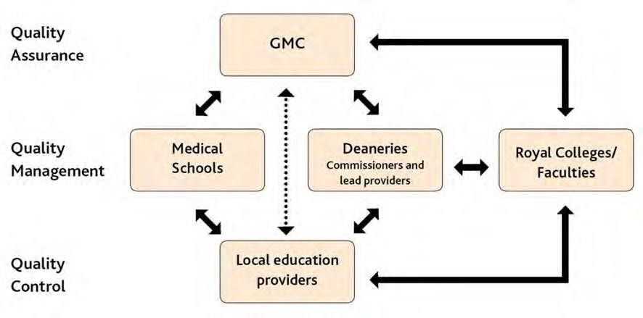
Figure 2: the GMC’s Quality Assurance Framework (QAF)

Alongside the Deanery’s responsibility for QM, the QAF requires Scotland’s LEPs to take responsibility for the Quality Control (QC) of the postgraduate medical education & training they provide, while the GMC Quality Assures the whole system to ensure that its standards for medical education and training are met. These standards covering the continuum of postgraduate medical education & training are clearly laid out in the GMCs Promoting excellence: standards for medical education & training, 2015 that replaces the previous separate standards for undergraduate & postgraduate medical education, respectively Tomorrow’s Doctors, 2009 & The Trainee Doctor, 2011

The Medical Directorate’s Quality workstream is responsible for the supporting infrastructure needed to meet these standards while the Scotland Deanery’s LDDs, Regional Postgraduate Deans and Regional GP Directors against the responsibilities outlined above, have clear accountability in delivering against the GMC standards, as delegated by the Responsible Officer (Medical Director) in keeping with the overarching delegated responsibility model.

The Quality Work stream is tasked with 4 essential aims:

- to scrutinise & manage the quality of postgraduate medical education & training provided within training environments within LEPs against the standards that have been set by the GMC,
- to effect improvements when deficiencies are identified and
- to identify and promote implementation of good practice in postgraduate medical education & training and thus
- support the quality improvement of medical education and training in all specialties, throughout Scotland.

These fundamental objectives are addressed through the supporting infrastructure of the Scotland
Deanery QM-QI framework. Again, organised around the Specialty Training Board Groupings, the Scotland Deanery QM-QI framework draws on their knowledge of the specialties they support and how training is organised across Scotland.

The Quality Workstream is led by a Postgraduate Dean, GP Director and General Manager overseeing teams of Associate Postgraduate Deans (APGDQ), Quality Improvement Managers (QIMs) and Quality Improvement Administrators (QIAs) who carry out QM and QI activities for the Lead Dean/Director assigned to a Specialty Grouping.

The assigned LDD as the accountable officer directs and controls these activities through a Specialty Quality Management Group (sQMG), The APGDQ, in association with QIMs, are responsible through their sQMG for managing the quality management processes for their specialties across Scotland.

This includes the outputs of visits, ensuring that agreed actions are responded to in a timely manner, reviewing and determining actions from the Scottish Trainee Survey (STS) and GMC National Training Survey (NTS) outputs as these become available and for managing responses to new notifications of concern and other patient safety information

Knowledge and feedback from the Scotland Deanery’s specialty Associate Postgraduate Deans is also a key consideration. Updates of entries in the online Dean’s report, required by the GMC, is also a responsibility of the sQMG with APGDQ and QIMs preparing these for LDD sign off.

The sQMG provides information to STBs regarding the quality of training in locations across Scotland within the specialty grouping for each STB and feeds information to the Deanery Quality Management Group(DQMG). The sQMG will have input into every STB meeting as a standing agenda item. This involvement is led by the APGDQ & QIM who both attend the STB. SQMGs meet approximately every 2 months as does DQMG.

The annual QM-QI cycle for each specialty grouping starts with the annual process of reviewing all the available current and new QM data, information & intelligence for each Specialty Grouping. This event, known as the specialty Quality Review Panel (QRP), is organised by each sQMG. Actions resulting from QRPs are progressed through the sQMG and related back to the DQMG and STB. QRPs are sequenced with Undergraduate, Foundation and GP QRPs held first to provide supporting feedback and intelligence where the specialty has Foundation or GP placements.

STBs include both Lay and College representation alongside trainee input to ensure transparency of process, appropriate external input to decisions, and good engagement of trainees. Specialty QRPs are chaired and led by the relevant LDD.

In turn, sQMGs report to the DQMG. The DQMG is the overarching group to which all eight sQMGs report. The DQMG is chaired by a Quality Workstream Lead or in their absence the General Manager for the Workstream.

The purpose of the DQMG is to have oversight of all the activities of sQMGs, including their QRPs. A key role is to coordinate visit activities where appropriate to minimise the burden placed on LEPs.

Other roles of the DQMG include improvement of the efficiency & effectiveness of the performance of the Scotland Deanery QM-QI framework and engaging in continual improvement of the QM-QI process itself. Further to this, the DQMG has responsibility for workstream performance review and oversees formal annual review of performance of QM- QI activities in each Specialty Grouping, by requiring an Annual Report and formal Annual Review meetings for each Specialty Grouping. The activities and responsibilities described above are categorised as ‘standard’. The Specialty Groupings also have responsibility for the management of the GMC Enhanced Monitoring process via the LDD who is accountable to MDET and the NES Board. A comprehensive summary of the Deanery’s and Quality Workstreams recent educational governance activity may be found in the Scotland Deanery Annual Quality Report.

How we support the governance of appraisal and revalidation of doctors in Scotland

The Medical Directorate is responsible:
a) for the revalidation of all doctors connected to NES, which includes all trainees
b) for providing the platform which supports appraisal and re-validation of all doctors in Scotland and c) for providing the training of all appraisers in Scotland.

The Directorate has delivered the GMC requirement to compile a register of recognised trainers in Scotland. In addition, it has further developed the extant Scottish On-line Appraisal and Revalidation tool (SOAR) in order that the state of readiness of trainers for recognition by NES as the Education Organisation (EO) is aligned to the annual appraisal, and the 5-year re-validation cycle.

Recognition of Trainers (RoT) is a GMC initiative that requires all secondary care trainers in two postgraduate roles (Educational Supervisor and Clinical Supervisor) and in two undergraduate roles to be suitably qualified and recognised as a trainer. The rationale for this initiative being “The quality of medical practice and the safety of patients are crucially dependent on the quality of the training provided to medical students and trainees”. Primary Care trainers are already subject to statutory approval by the GMC.

The RoT Project was set up in response to the GMC requirements following a previous NES project, The Faculty Development for Scotland Project, a multi-stakeholder initiative to ensure all medical trainers in Scotland were appropriately trained.

When the GMC requirements to recognise all secondary-care trainers were announced in 2012 the work previously completed allowed development of a single-system approach in Scotland to meet the new requirements. A Project Board was established with representatives from the various stakeholder groups, NES Medical Directorate Executive Team (MDET), the Directors of Medical Education (DME) Group representing all 14 territorial Health Boards and the Scottish Deans Medical Education Group (SDMEG) representing all five Medical Schools.

The aim of the project was to ensure the GMC requirements for RoT were achieved efficiently and effectively across Scotland. These requirements were set out in an Implementation Plan published by the GMC in 2012 where four milestones were identified. The final milestone was “to confirm that all medical trainers in the four roles, or entering any of the four roles, are fully recognised i.e. have met the Education Organiser (EO) criteria, without use of interim concessions by 31 July 2016”.
In Scotland the six EOs are NES, and the five Medical Schools. EOs have responsibility for recognising trainers eligible for the four “named” roles and setting criteria to meet the RoT requirements which are based on the seven areas in A Framework for the Professional Development of Postgraduate Medical Supervisors published by the Academy of Medical Educators (AoME)

The process to recognise trainers uses the Scottish Online Appraisal and Revalidation (SOAR) system with specially designed RoT pages to be completed as part of the annual appraisal process and reviewed with the trainer’s appraiser. Following appraisal SOAR confirms if the trainer has declared whether they are ready for recognition/re-recognition and a Form 7 is generated for review by the DME and the relevant EO(s), which identifies only issues related to RoT. The DME is required to make a recommendation about eligibility for recognition based on the eligibility criteria set out in the Scottish Trainers Framework.

The final recognition/re-recognition decision is made by the relevant EO (NES or the Medical School) based on the trainer’s Form 7 and DME recommendation. The DME is also required to ensure appropriate local systems are in place to oversee the appointment of named trainers and are documented. Newly appointed trainers are required to complete the RoT process on SOAR at their next appraisal following appointment. Once recognised a trainer retains this status until their next clinical revalidation date when they also require to be re-recognised as a trainer, or the status is removed due to a Quality Management review by the EO or the trainer being subject to a Fitness to Practice investigation. RoT decisions in Scotland are quality assured.

